2023

INTERNET OF THINGS 271/281



Student Names:

Njabulo Marrengane (577729)

Tadiwanashe Nyoka (577633)

Thandeka Mavunda (577949)

Thembekile Magalele (577597)

Lecturer: Mrs Privilege C Tavagwisa

Due Date: 5 October 2023

Contents

Introduction 2

Design in TinkerCard 3

Arduino Sketch 4

Circuit Schematic 6

# Introduction

It is crucial to provide safety and security in the fast-paced world of today. This is essential for the quick identification of possible dangers like gas or smoke leaks. We provide a full solution—a smoke detection system run on an Arduino Uno—to meet this demand. Innovative technologies and user-friendly interfaces are combined in this system to produce a dependable and effective safety mechanism.

The objective of this project is to develop a smoke detection system that can quickly warn users of hazardous smoke or gas levels. The MQ-2 gas sensor will sound a buzzer and flash a red LED to signal an alert when it detects such levels. Until a reset is started by pushing a usually open pushbutton, the alarm will keep going off. A 16x2 LCD display will give consumers real-time feedback on the status of the system.

# Design in TinkerCard

Link to circuit on TinkerCard:

[Copy of PROJECT IOT 2871 (tinkercad.com)](https://www.tinkercad.com/things/3Jd3CYopULd?sharecode=Yj-B0U3FEaja5CD9H4XA8wC6XyRBBlYRPsuoyqCZLFY)

# Arduino Sketch

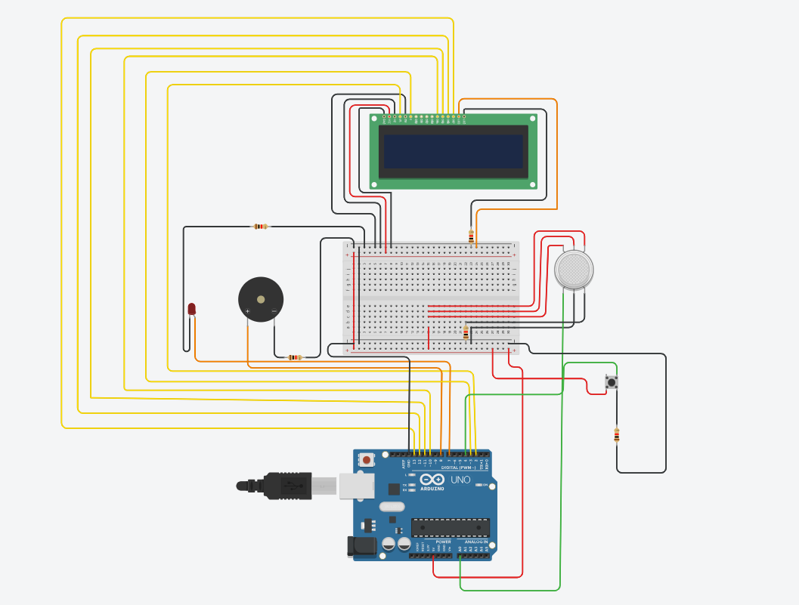

An MQ-2 gas sensor, a piezo buzzer, a red LED, a pushbutton, and a 16x2 LCD are used to build a smoke detection system in this Arduino programme. The output of the gas sensor is continually monitored, and when a certain amount of gas is reached, the alarm (LED and buzzer) is turned on. By depressing the pushbutton, the alarm can be reset.

When constructing the hardware, the proper pins are needed to be used to link the MQ-2 gas sensor to the microcontroller (such as an Arduino). The 5V output of the Arduino should connect to the VCC pin of the MQ-2 sensor. The sensor's GND pin should then be connected to the Arduino's GND (Ground) output. Connect the sensor's OUT output to an Arduino analogue input pin, such as A0.

The red LED and piezo buzzer are also connected to the microcontroller. One of the piezo buzzer's legs should be connected to an Arduino digital pin, such as D8. The other buzzer leg should be connected to the Arduino's GND pin. The red LED's longer (anode) leg should connect to a current-limiting resistor. Then join the resistor's other end to an Arduino digital pin, such as D7. The LED's shorter leg (cathode) should be connected to GND. Using the required connections, the 16x2 LCD are joined to the microcontroller. Where necessary, add resistors to provide proper voltage levels while also protecting the components. To reset the system, connect the usually open pushbutton to the microcontroller. One pushbutton leg should be connected to an Arduino digital pin. The pushbutton's other leg should be connected to GND. Then connect the digital pin to 5V using a pull-up resistor.

To determine the amount of smoke present, the system reads analogue readings from the gas sensor (A0). The red LED lights on, the buzzer sounds, and the LCD displays "ALERT" if the analogue value exceeds the set threshold (sensorThresh) and the button (attached to pin 4) is not depressed (LOW). It eventually shows "EVACUATE." The evacuation procedure has started, and a message is shown, if the analogue value above the threshold and the button is pressed (HIGH). The "SAFE" and "ALL CLEAR" messages are shown, and the LED and buzzer are turned off, if the analogue value is below the threshold.

# Circuit Schematic

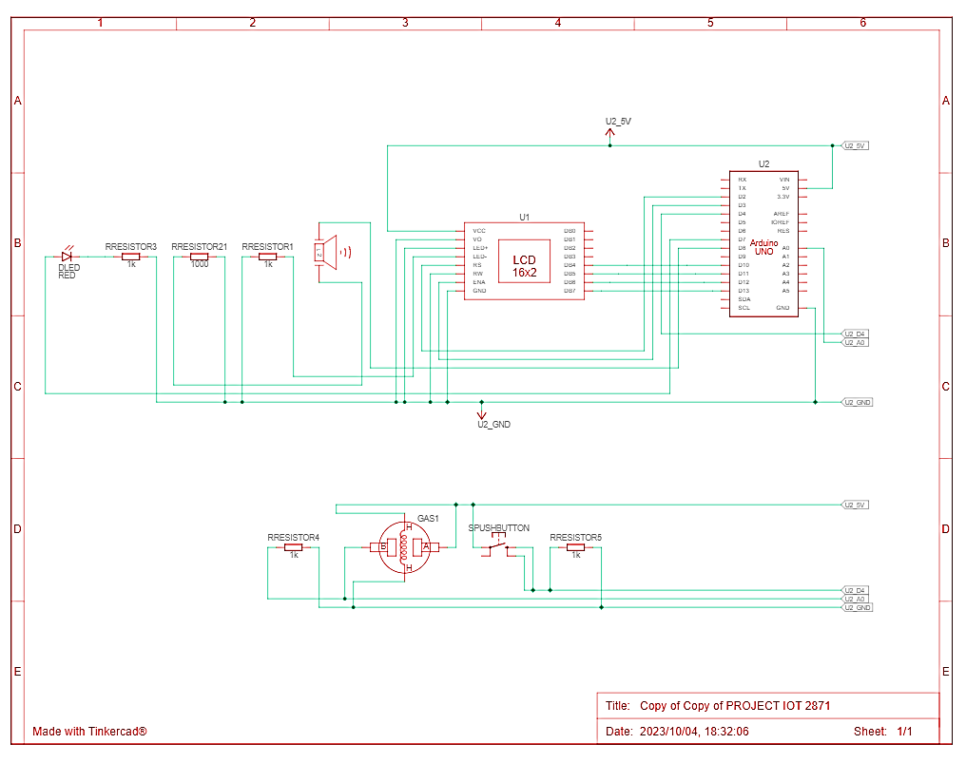

The circuit schematic diagram above simplifies the electric circuit that was built. The diagram assists one to design, construct, and maintain the electrical circuit. The schematic diagram can be used to gain insight into the general way the electrical circuit functions. Therefore, it eliminates the need to detail the hardware or software used in the electrical circuit itself. It also helps one discover or notice any parts of the electric circuit that needs to be corrected prior to building the electrical circuit. By incorporating a schematic diagram, it may also be seen as saving time when attempting to build the electrical circuit.